20BCE1837

EX No. 7

Date: 24.9.2022

AIM: To execute DOM, AJAX and jQuery in an HTML website.

Procedure:

1. Type the JavaScript functions and save in a .js file.

2. Link the .js file to the .html file.

3. Open the .html file inside a web browser.

CODE:

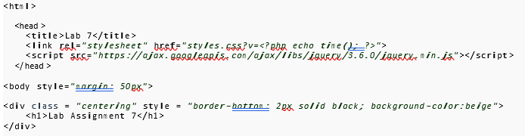

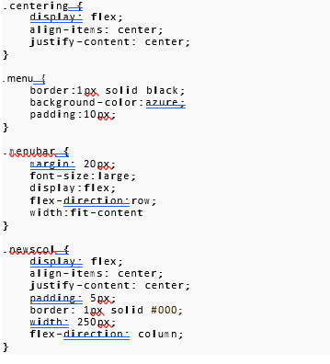

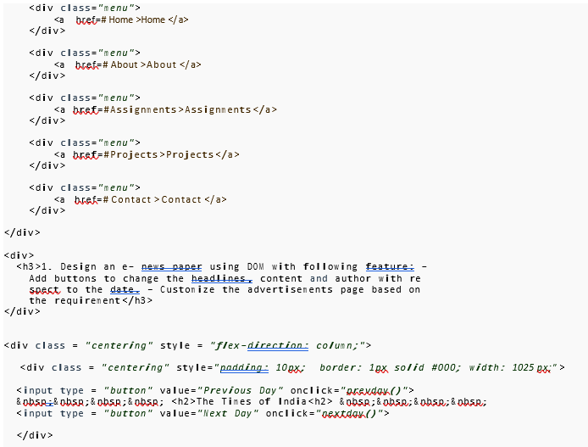

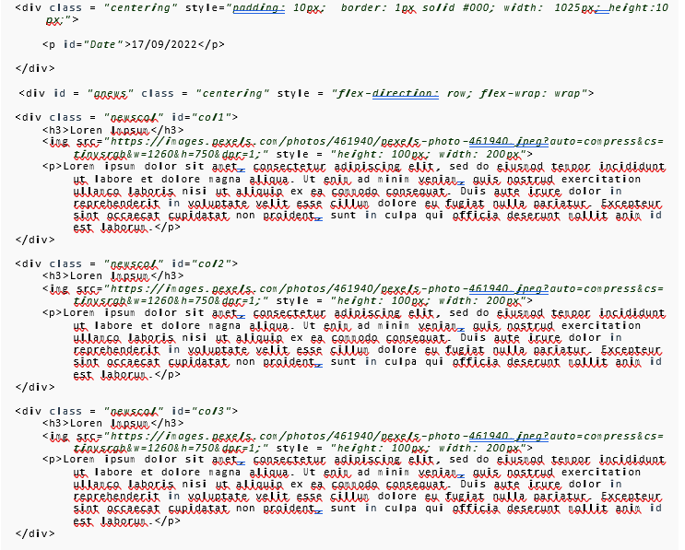

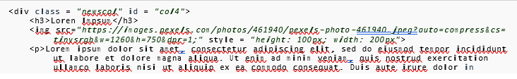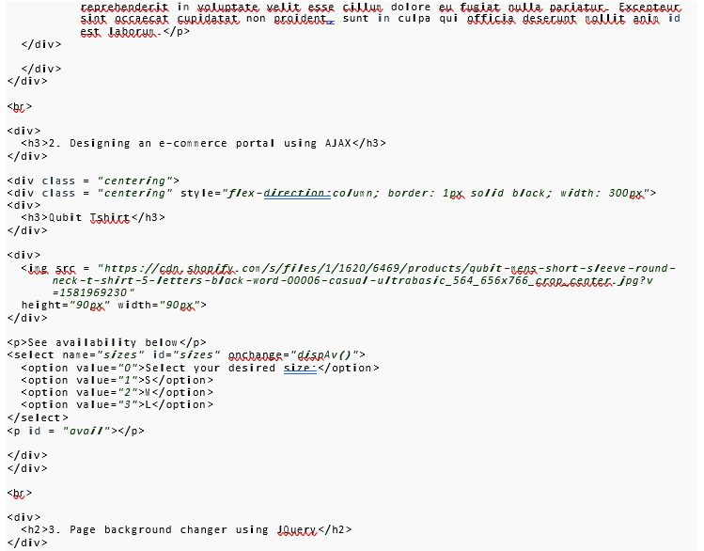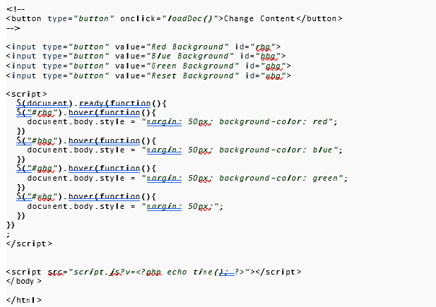

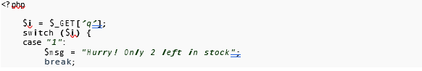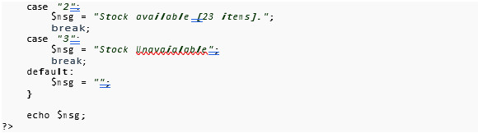

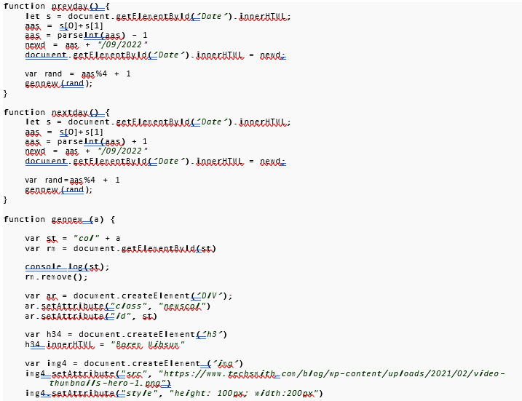

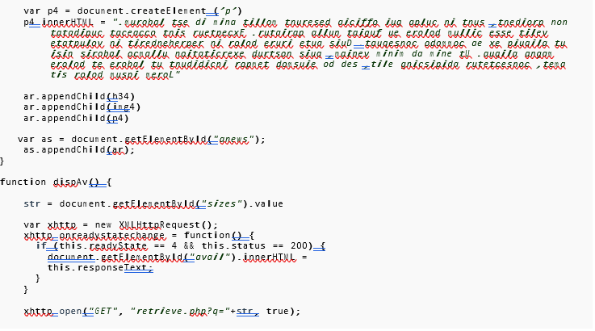

OUTPUT:

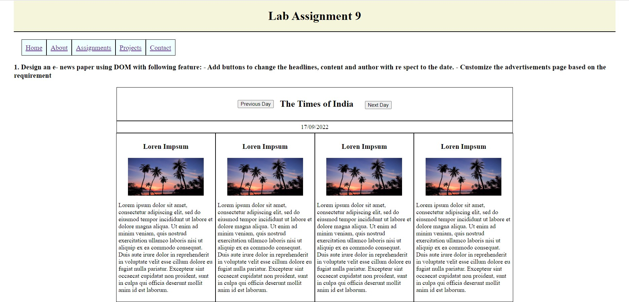QUESTION 1:

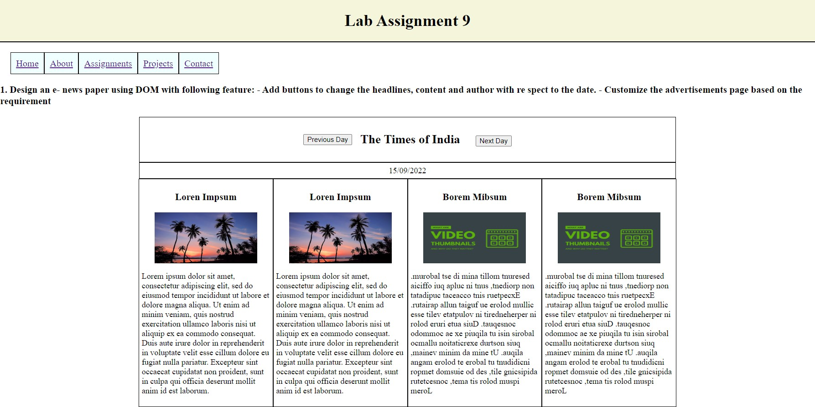

QUESTION 2:





QUESTION 3:



RESULTS: Thus, DOM, AJAX and jQuery were successfully implemented